Screen Design for Super Sighting Database

Table of Contents
Table of Contents
Table of Contents 1
Home Screen 1
Super Hero/ Villians and Edit Screen 1
Super Powers and Edit Screen 1
Locations and Edit Screen 1
SuperHero Organization and Edit Screen 1
Organizations and Edit Screen 1
Sightings and Edit Screen 1

Home Screen
The home screen has to show the main layout and a News Feed of the latest 10 items
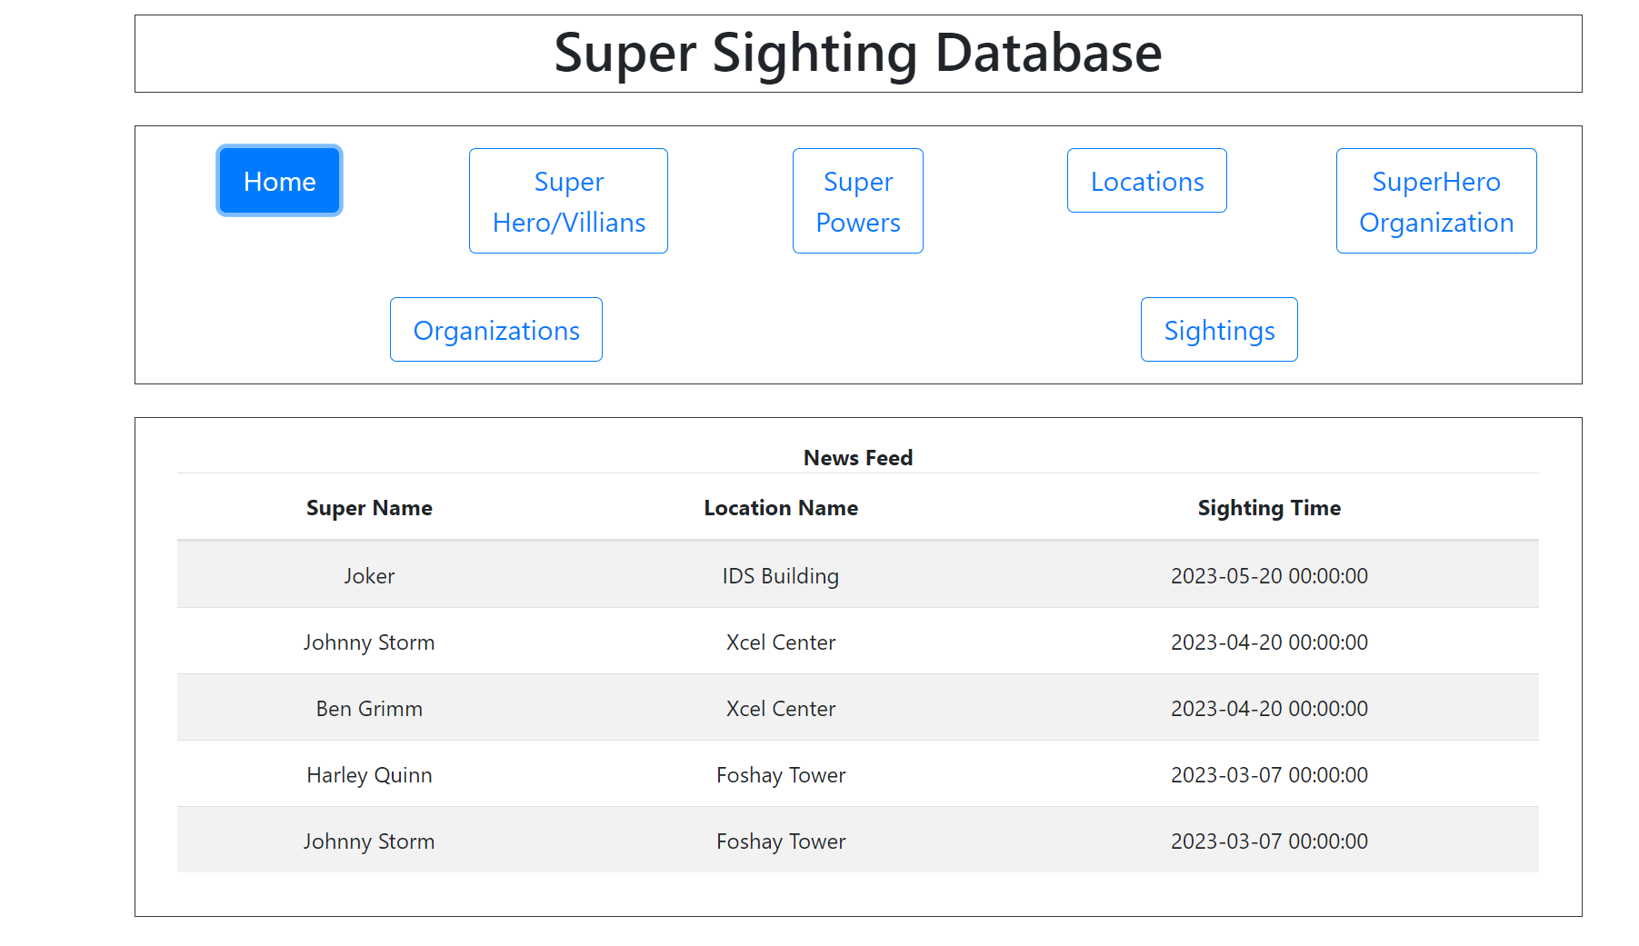

Super Hero/ Villains and Edit Screen

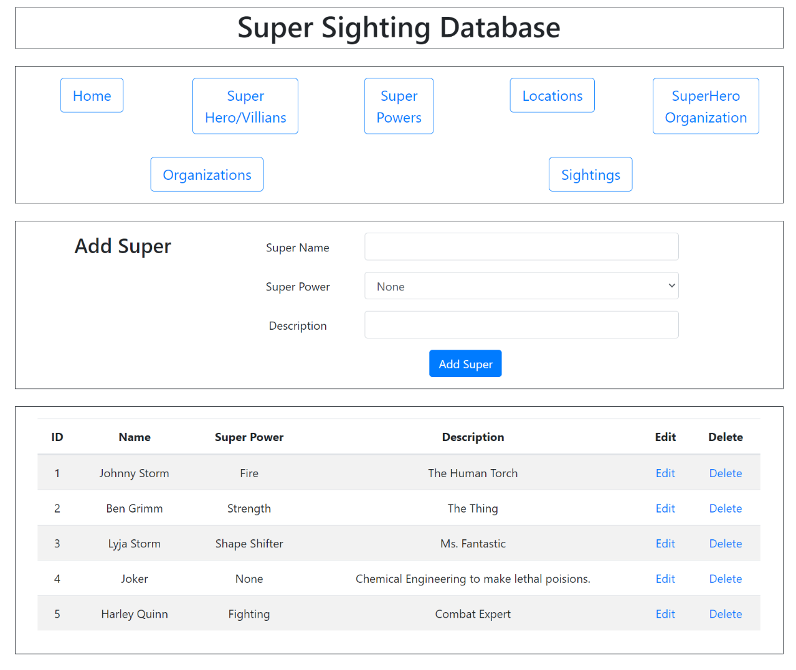
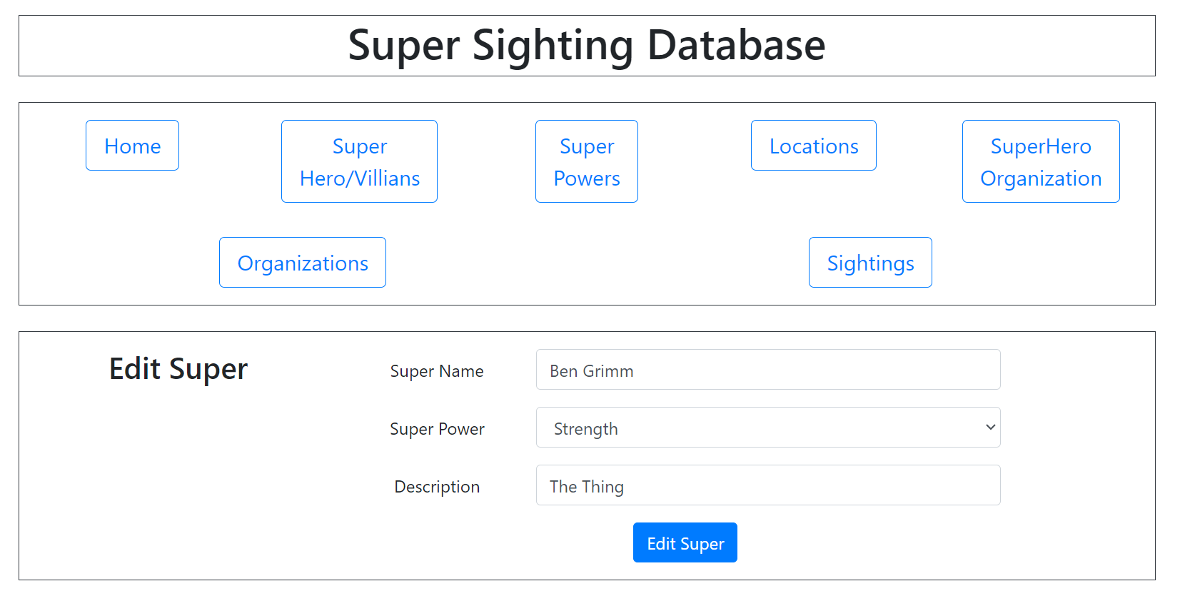

Super Powers and Edit Screen

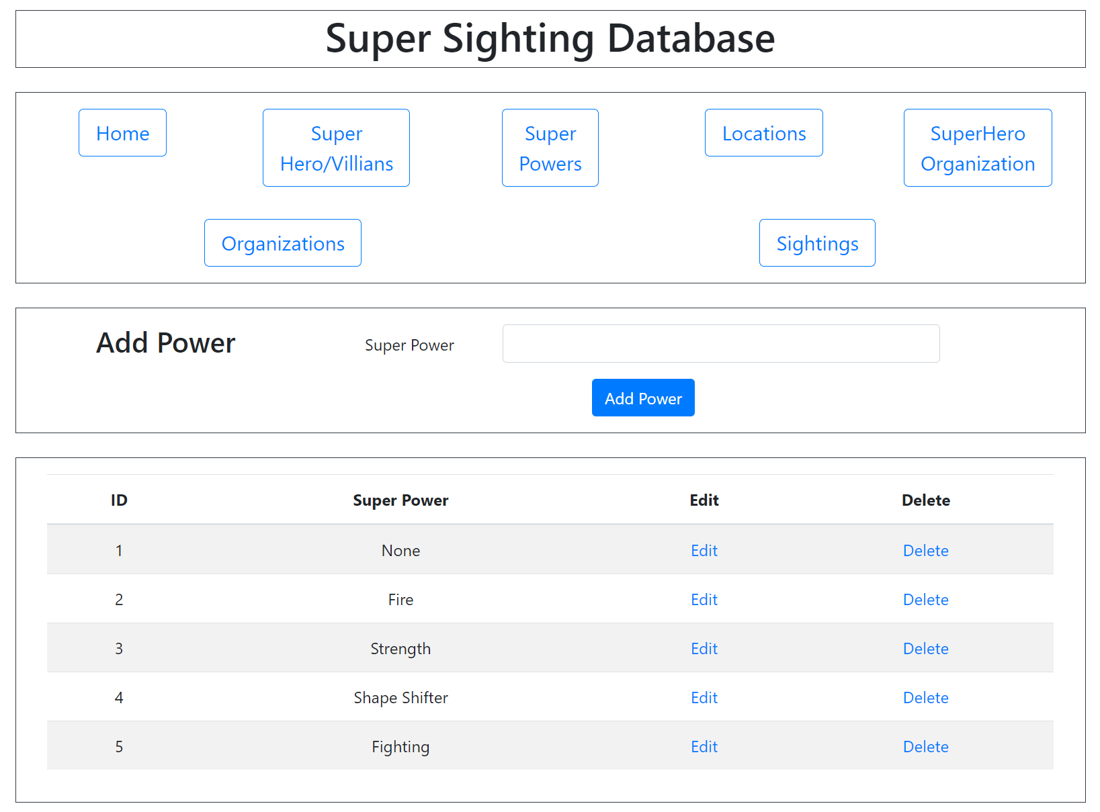
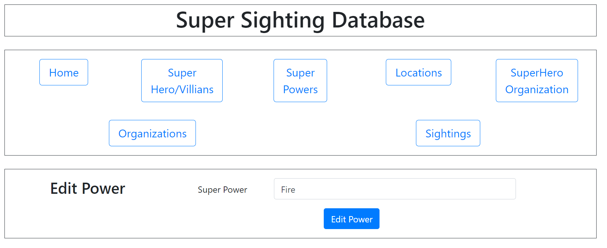

Locations and Edit Screen
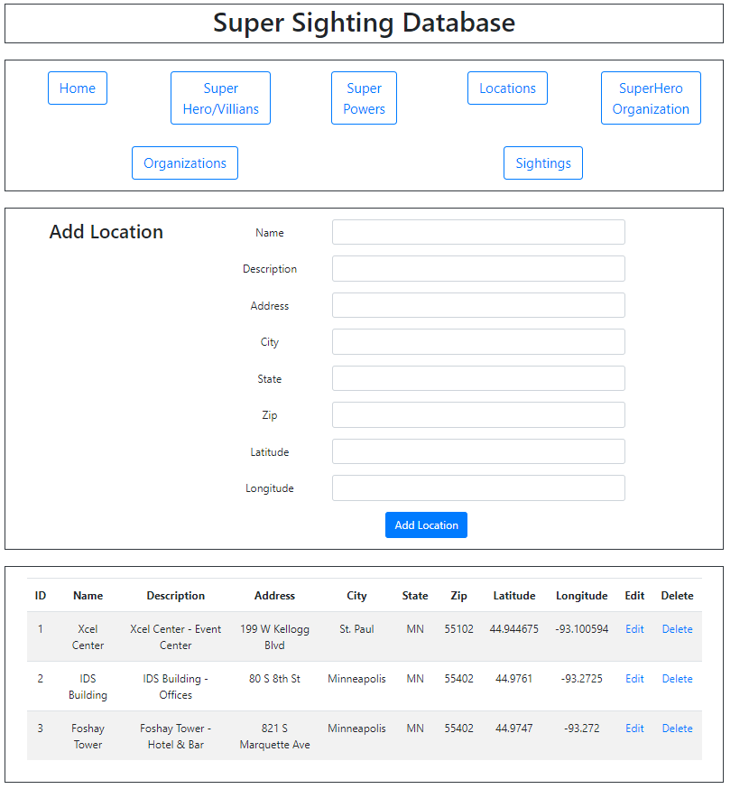
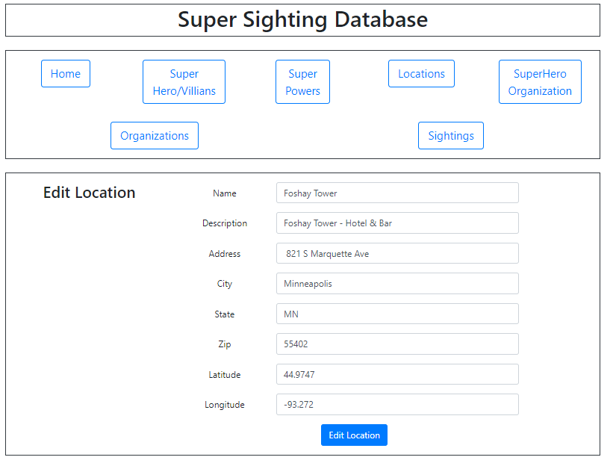

SuperHero Organization and Edit Screen

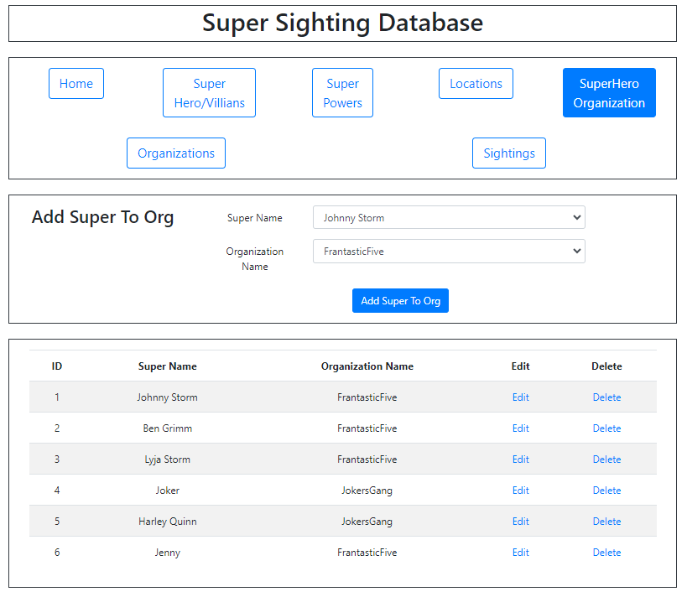
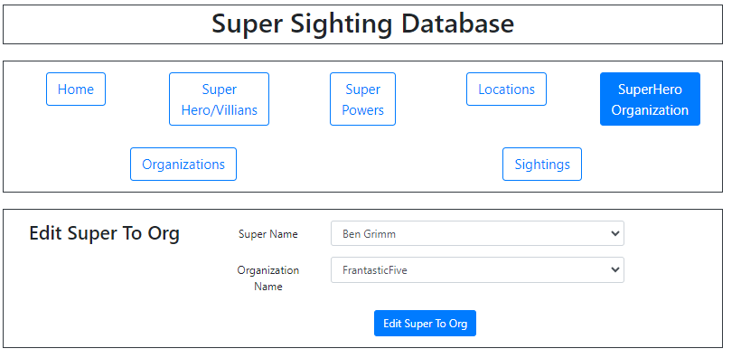

Organizations and Edit Screen
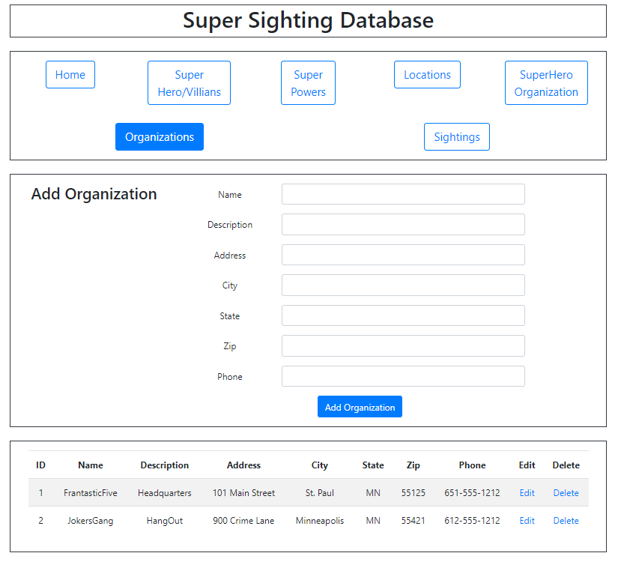

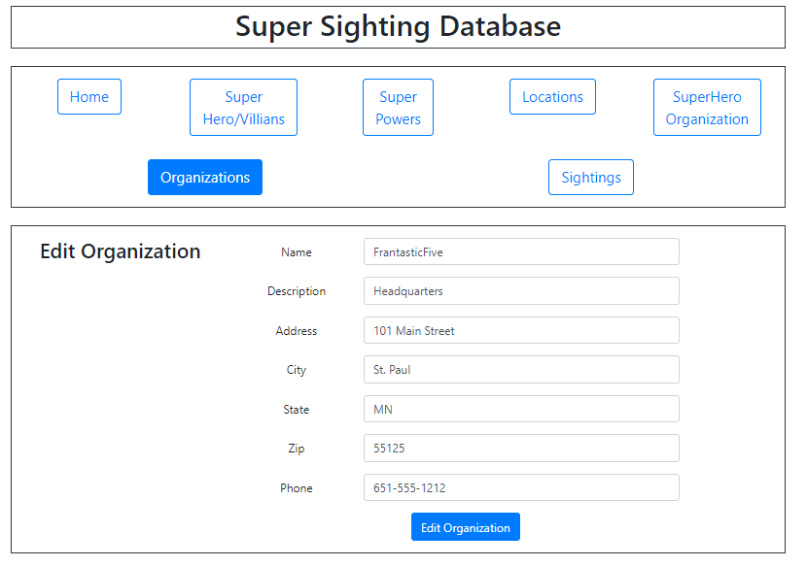

Sightings and Edit Screen
